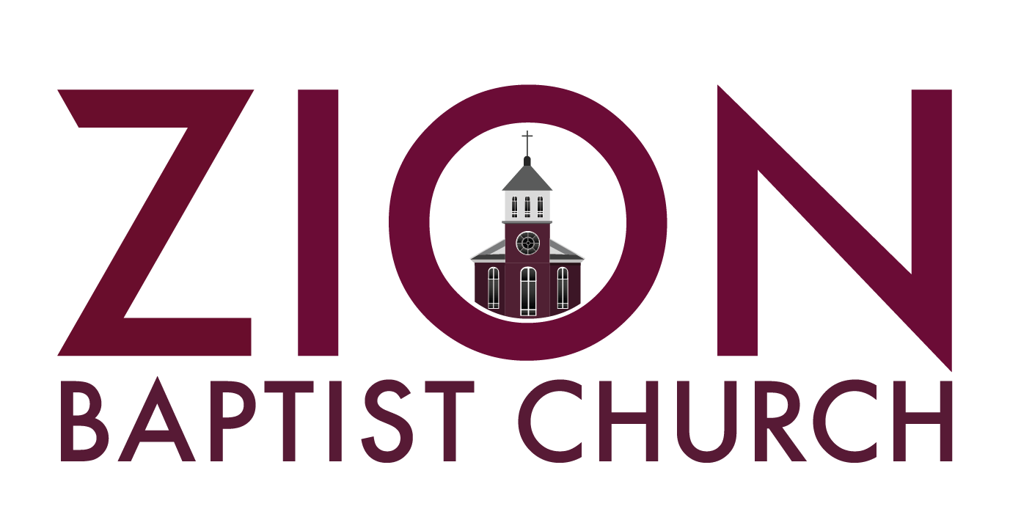
High School Graduating Class of 2023
Scholarship Application

INFORMATION AND GUIDELINES

Objectives
Zion Baptist Church (ZBC) has an ongoing commitment to the education process, and a desire to recognize the accomplishments of high school graduates who attempt to further their education. This Zion Baptist Church scholarship is given to encourage young high school graduates to pursue the goal of achieving excellence through higher education. We hope that those identified through this scholarship will exemplify not only excellence in academics, but also spiritual leadership in the community as well.

Funds for the scholarships are provided by Zion Baptist Church and are used solely for the graduating seniors of the church to support the youth of ZBC graduating from high school.

Award Value
The amount of the scholarship is based on the availability of funds and the number of applicants applying for scholarships. The number of awards will be determined after all applications are received. All scholarship funds are sent directly to the students for tuition, textbooks, and other fees.

Every applicant that meets the established criteria will receive a scholarship. In addition to fund availability and the number of candidates, the amount will be determined based on the eligibility criteria listed below.

Eligibility
- Candidates must meet all the following criteria:
- You or a family member MUST be a member of Zion Baptist Church for at least one (1) year (12 months) prior to the start of the “Graduate Program” sessions. (January 2023)
- Attend a minimum of 7 out of 10 “Graduate Program” sessions hosted by the Scholarship Committee. Sessions will take place on Wednesday nights, from January 18 - March 29, 2023.
- Be accepted by an accredited school providing education or training certification above the secondary level or military acceptance. (Documentation required)
- Be a high school graduate within the last 12 months of application.
- Maintain a grade point average (GPA) at 2.0 or above.
- Applications must be received on or before March 29, 2023, before 11:59 p.m. (No late application will be accepted.)
- Applicants must submit the following items:
- Zion Baptist Church Scholarship application (see enclosed application)
- Recommendation form from a high school counselor (see enclosed form)

- Letter of recommendation from a community or church leader
- An official high school transcript
- Personal essay (choose one of the topics and follow all instructions)
- Submit the acceptance letter prior to May 28, 2023.

NOTE: The counselor’s recommendation form and the letter from the community or church leader should be emailed to HYPERLINK "mailto:scholarshipcommittee@zbcmarietta.org" scholarshipcommittee@zbcmarietta.org.

Procedure
Candidates must submit the following:
Zion Baptist Church Scholarship Application: Typed, not handwritten
High School Counselor’s Recommendation Form
An official high school transcript sent from the High School Counselor
Recommendation letter from a community member or church leader: Typed, not handwritten
An original Personal Essay: Typed, not handwritten 12 pt. font Times New Roman

All application materials must be typed, completed in their entirety, and submitted on or before March 29, 2023 at 11:59 pm to the Zion Baptist Church Scholarship Committee at HYPERLINK "mailto:scholarshipcommittee@zbcmarietta.org" scholarshipcommittee@zbcmarietta.org.

NO APPLICATIONS WILL BE ACCEPTED AFTER THE ESTABLISHED DEADLINE.

SCHOLARSHIP APPLICATION: PART 1
(Please type your responses)

NAME: __________________________ __________________________ __________
LAST FIRST MI

ADDRESS: __________________________________ _____________________ ____________
STREET CITY ZIP

Preferred Phone Number: (___) ___________________ DATE OF BIRTH: ________________________

EMAIL ADDRESS: _______________________________________________________________________________

NAME OF PARENT/GUARDIAN(S): _______________________________________________________________________________

MOTHER PHONE # ______________________________EMAIL____________________________________________

FATHER PHONE # _______________________________EMAIL___________________________________________

GUARDIAN PHONE #_____________________________EMAIL____________________________________________

HIGH SCHOOL GRADUATING FROM: ______________________________ GPA: ___________

WHAT COLLEGE(S) OR CAREER TRAINING PROGRAM HAVE YOU APPLIED FOR ADMISSION OR BEEN ACCEPTED TO? (List in order of preference)

Please provide a copy of the acceptance letter for the college/technical school, or branch of the military in which you have been accepted by May 28, 2023 and email to: scholarshipcommittee@zbcmarietta.org.

1) __________________________________ 2) ________________________________

3) ___________________________________ 4) ________________________________

LIST THE ZION BAPTIST CHURCH YOUTH MINISTRY ACTIVITIES IN WHICH YOU HAVE PARTICIPATED:

DUTIES/LEADERSHIP ROLES HOW LONG?
_____________________________________________ _________________

_____________________________________________ _________________

_____________________________________________ _________________

_____________________________________________ _________________

_____________________________________________ _________________

_____________________________________________ _________________

_____________________________________________ _________________

_____________________________________________ _________________

_____________________________________________ _________________

SCHOLARSHIP APPLICATION: PART 2
(Please type your responses)

Directions for Personal Essay

Choose one (1) of the following topics below:
What do you think the church’s role is in today’s society and how can we as Christians help better the society we live in?
What are your views on social injustices and systemic racism that we are experiencing in our country?
How do you plan to impact society positively with your college degree?
What social or economic issues matter most to you and why?
How has COVID-19 affected the way that we learn? In your opinion, is it positive or negative?

Research may be used or referred to, but the essay must be an original document constructed by the student. If any sources are used, all sources must be cited, using APA or MLA format.

Type a 300 or more-word essay; 12-point font, Times New Roman

COMPLETED APPLICATION AND ESSAY MUST BE SUBMITTED BY MARCH 29, 2023 before 11:59 p.m.

EMAIL COMPLETED APPLICATION AND ESSAY TO:
scholarshipcommittee@zbcmarietta.org.

CHECKLIST OF REQUIRED ITEMS TO BE SUBMITTED

- Application
- Personal Essay
- Community or Church Leader Recommendation Letter
- Official Transcript (MUST BE SUBMITTED BY COUNSELOR)
- Counselor Recommendation Form (MUST BE SUBMITTED BY COUNSELOR)
- Must attend 7 out of 10 Wednesday night “Graduate Program” sessions.
- Documentation (acceptance letter) are due no later than May 21, 2023.

THANK YOU.

FOR QUESTIONS, CONTACT:

DEACON MIKE MCCLOUD
Chair, ZBC Scholarship Committee
770-630-4222
scholarshipcommittee@zbcmarietta.org

